


DATA SHEET
MAGicBeads Protein G

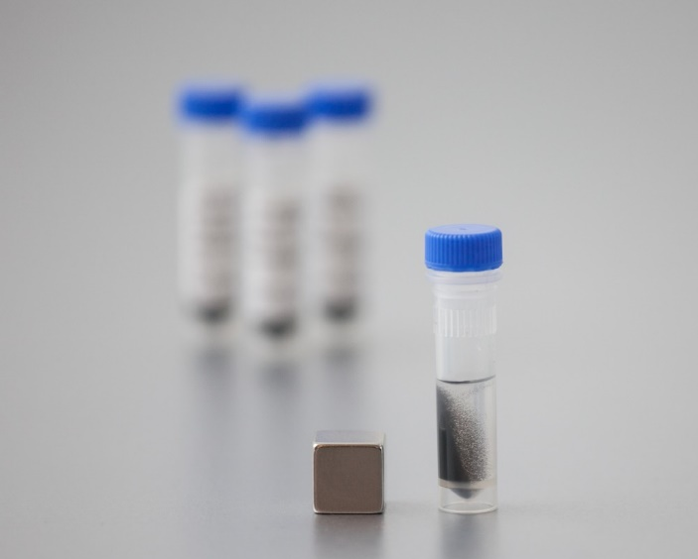
MAGicBeads Protein G

Super-paramagnetic porous beads
- High binding capacity >65 mg IgG/mL
- High affinity to IgG species from multiple sources
- Minimal non-specific interaction

MAGic™Beads Protein G provides a simple and effective system for isolation of antibodies using magnetic separation techniques. This product is intended for purification of monoclonal antibodies from cell culture harvests, such as from hybridoma or CHO cells.
The beads are spherical porous agarose beads (average size of 55 µm) with an optimal pore size for antibodies, that have been magnetized to become super-paramagnetic. Agarose-based beads are inert and hydrophilic, preventing nonspecific interactions and are compatible with all kinds of biomolecules. A recombinant Protein G has subsequently been coupled to this bead to produce MAGicBeads Protein G. See Table 1 for the bead characteristics.
The black beads are easily observed by the naked eye, making them easy to follow and collect, and they do not aggregate, which facilitates the resuspension. The quantity of the high-capacity beads can easily be scaled up or down to match the antibody concentration and sample volume.

Table 1. Main characteristics of MAGicBeads Protein G
Product | MAGicBeads Protein G, 10% bead suspension
Target molecule | Antibodies (IgG), bound via the F_{c}-region
Matrix | Super-paramagnetic porous agarose
Ligand | Recombinant Protein G
Average particle size (DV50 )¹ | 55 µm
Maximum binding capacity^{2 ,3} | >65 mg IgG/mL settled beads
Practical binding capacity^{2, 4} | 45 mg IgG/mL settled beads
Chemical stability | Compatible with all standard aqueous buffers used for protein purification.
Storage | +2 to +8°C in 20% ethanol.
- The median particle size of the cumulative volume distribution
- Binding capacity for human polyclonal IgG at a titer of 5 mg IgG/mL.
- The maximum binding capacity is performed under IgG excess to allow all ligands to bind to targets (saturated conditions)
- The practical binding capacity is at 90% binding of targets to ligands. This value is always lower than the maximum capacity

Applications

Principle
MAGicBeads Protein G is a magnetic affinity separation media with high affinity for antibodies, specifically IgG, from various species. This capture step generates high yields and purities of antibodies in a single step and is therefore commonly used in antibody purification processes or in immunoprecipitation protocols. The 55 µm super-paramagnetic MAGicBeads are based on crosslinked porous agarose.

Varied affinities for IgGs from different sources
Protein G binds IgG antibodies with high affinity across a broad range of species and subclasses (see Table 2 below), making it more versatile than Protein A in many applications. Its broad binding profile makes Protein G a valuable tool for IgG isolation and purification, particularly in small-scale purification workflows and immunoprecipitation assays.

Table 2. Antibody affinity to Protein A and Protein G
Species | IgG class | Protein A | Protein G | Species | IgG class | Protein A | Protein G
Human | IgG1 | ++ | ++ | Rabbit | IgG | ++ | ++
 | IgG2 | ++ | ++ | Hamster | IgG | + | ++
 | IgG3 | – | ++ | Guinea Pig | IgG | ++ | +
 | IgG4 | + | ++ | Bovine | IgG | + | ++
 | IgA | + | – | Horse | IgG | + | ++
 | IgD | + | – | Sheep | IgG | +/– | ++
 | IgE | + | – | Goat | IgG | +/– | ++
 | IgM | + | – | Pig | IgG | ++ | ++
Mouse | IgG1 | + | ++ | Chicken | IgY | – | +/–
 | IgG2a | ++ | ++
 | IgG2b | ++ | ++ | Antibody fragments
 | IgG2c | + | ++ | Human | Fab | + | +
 | IgM | +/– | – |  | F(ab’)2 | + | +
Rat | IgG | ++ | ++ |  | scFv | + | –
 | IgG1 | +/– | + |  | Fc | + | +
 | IgG2a | +/– | ++ |  | κ | – | –
 | IgG2b | +/– | + |  | λ | – | –
 | IgG2c | +/– | +
 | IgM | +/– | –
++ strong | + moderate | – low | +/– needs evaluation

References:
Richman DD, Cleveland PH, Oxman MN, and Johnson KM. (1982) The binding of Staphylococci Protein A by the sera of different animal species. J Immunol 128, 2300-2305.
Frank MB. (1997) Antibody Binding to Protein A and Protein G beads. In: Frank MB, ed. Molecular Biology Protocols. Oklahoma City.

High binding capacity for different sources at varied titers (BC)
There is a positive correlation between binding capacity and antibody concentration. MAGicBeads Protein G has a broad dynamic range in capacity to bind antibodies at decreasing titers (from large scale purifications to screening and low titer detection applications).
For high IgG concentrations ≥ 5 mg/mL:
  - Maximum BC: 65-80 mg/mL (human IgG)

For low IgG concentrations of 0.1 mg/mL:
  - Maximum BC: 18-20 mg/mL (human IgG)
  - Maximum BC: 13 mg/mL (mouse IgG)
Similar binding capacity values are obtained regardless of purity of IgG loaded (e.g., pre-purified IgG vs. IgG expressed in feed).
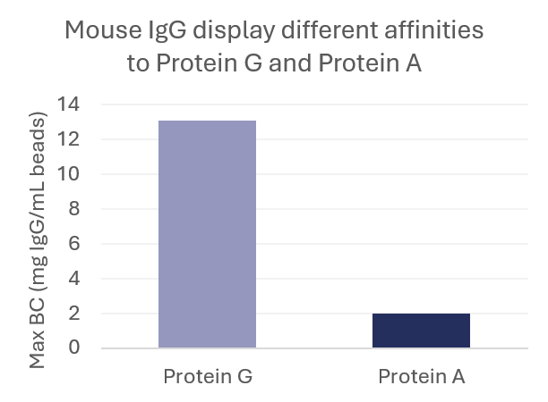
Mouse IgG is an example of an antibody that typically does not bind well to Protein A, but has a high affinity to Protein G. See Figure 1 below.
Figure 1. Mouse IgG expressed in Escherichia coli at a titer of 0.1 mg/mL was purified on MAGicBeads Protein G vs. MAGicBeads Protein A+.

To investigate the correlation between antibody titer and binding capacity, a binding study was performed using purified human IgG at concentrations ranging from 0.1 to 5 mg/mL. Beads were added to the antibody samples at optimized bead-to-antibody ratios in PBS buffer and incubated for 1 hour at room temperature under continuous mixing. The experimental conditions are summarized in Table 3. Maximum binding capacities were determined as a function of IgG concentration, and the results are presented in Figure 2.
Table 3. Experimental condition for binding studies to investigate the correlation between IgG titer and binding capacities. Last column displays the binding capacities obtained under the specified conditions.

# | IgG concentration (mg/mL) | Reaction volume (mL) | Bead volume (µL) | Binding capacities (mg IgG/mL)
1 | 5 | 1 | 50 | 72
2 | 2 | 1 | 50 | 32
3 | 0.1 | 2 | 10 | 19

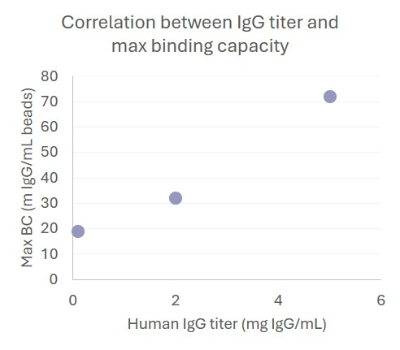
Figure 2. Maximum binding capacities of human IgG (pure) to MAGicBeads Protein G at increasing titers ranging from 0.1 mg/mL up to 5 mg/mL.

Practical binding capacity - calculations
The difference between maximum binding capacity (Q_{max}) and the practical binding capacity is that the former test is performed under an IgG excess at a defined titer to allow all ligands to bind to the target, whereas the practical binding capacity targets a 90% binding of targets to ligands. The measured Q_{max} is therefore always higher than the practical binding capacity.
The practical binding capacity at different antibody titers should be tested for each specific antibody to obtain correct capacity values. Based on the practical binding capacity values at different titers, the optimal amount of target-bead ratio can be calculated. See the instructions for these calculations.

High yields achieved in purifications from complex feeds
In monoclonal antibody purifications the yield is of utmost importance and should preferably exceed 80%. To verify the yield obtained using MAGicBeads Protein G, purifications were conducted on multiple batches and evaluated.
IgG1 expressed in Chinese Hamster Ovary (CHO) cells at a titer of 1.3 mg/mL was purified on MAGicBeads Protein G. 464 µL 10% bead slurry was equilibrated in PBS and 1 mL of antibody feed was added. The suspension was incubated for an hour under stirring and after 3 wash steps, was eluted in 100 mM glycine buffer, pH 2.7. For yields from purifications on different MAGicBeads Protein G batches, see Table 4 below.
MAGicBeads Protein G batch | Eluted IgG1 yield (%)
Batch A | 85
Batch B | 85
Batch D | x
Table 4. IgG1 elution yield from MAGicBeads Protein G after 1-hour adsorption. IgG1 was expressed in CHO cells at a titer of 1.3 mg/mL.

Yields dependent on pH
The interaction between antibodies and Protein G is destabilized at low pH, and an elution buffer at approximately pH 3 is therefore commonly used for antibody recovery. However, antibodies are prone to aggregation under acidic conditions, making it desirable to perform elution at the highest possible pH while maintaining acceptable recovery. The optimal elution pH is antibody-dependent and must therefore be determined empirically. As elution efficiency generally decreases with increasing pH, a balance must be achieved between maximizing recovery and minimizing aggregation.
To investigate the effect of elution pH, mouse IgG was eluted using 100 mM glycine buffers with pH values ranging from 2.5 to 3.0. Two mL of IgG expressed in Escherichia coli cells at a titer of 0.1 mg/mL were purified on 15 µL MAGicBeads Protein G beads. As expected, the elution efficiency was highest at pH 2.5, resulting in an approximately 25% higher elution yield compared with pH 3.0 (Figure 3). Depending on the intended application, the trade-off between higher recovery at lower pH and the increased risk of antibody aggregation should be carefully considered.
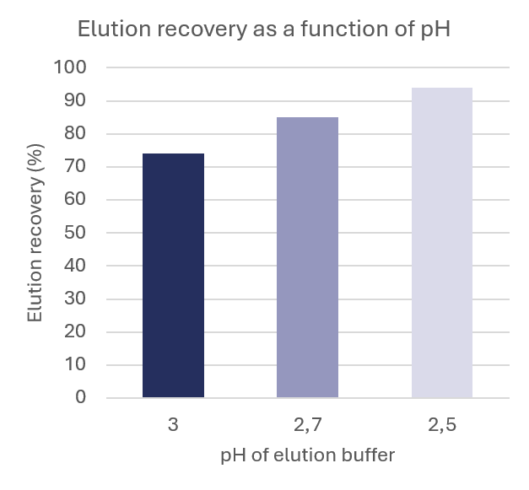
Figure 3. Elution yield as a function of elution pH. Elution yields from a purification of a low titer (IgG expression of 0.1 mg/mL) mouse IgG E. coli feed using MAGicBeads Protein G are shown following elution with 100 mM glycine buffer at pH 2.5, 2.7, and 3.0.

Super-paramagnetism
MAGicBeads are super-paramagnetic beads, where magnetic separation occurs within seconds at small scale (1 mL), due to our novel proprietary production method. These beads are easily resuspendable without forming any aggregates facilitating the separation process. This is due to the property of the agarose beads being hydrophilic and the lack of a magnetic memory. These properties speed up the protocols at all scales.

Scale-up
The beads are suitable for separations using appropriate magnetic separators, such as the MAGicAccio LAB, MAGicAccio PILOT 50, MAGicAccio PILOT 500, MAGicAccio PILOT 2000 and MAGicAccio PROCESS.
These separators vary from lab scale to medium scale/process development up to large scale/bioprocessing scale.
MAGic BioProcessing’s proprietary PROCESS technology simplifies antibody recovery by combining clarification and capture into one scalable process. Using MAGicBeads Protein G to isolate antibodies directly from complex feedstocks, and paired with our automated magnetic separation system, the platform creates a smooth link between upstream and downstream operations — improving efficiency and saving time.
Ref: Nils A. Brechmann et al. 2024. Side-by-Side Economic Process Model for the Comparison and Evaluation of Magnetic Bead-Based Processes and Legacy Process for the Manufacturing of Monoclonal Antibodies. Processes.

Cleaning-in-place/ sanitation
Protein G is a native protein ligand and therefore lacks alkali stability. To maintain high binding capacity during repeated CIP cycles, NaOH should be avoided or be kept to a minimum.
Alternative cleaning strategies include the use of non-ionic detergents, chaotropic agents, and high-salt washes to remove accumulated contaminants. In addition, treatment with 20–70% ethanol can help reduce microbial contamination and remove hydrophobic fouling from the resin. 6 M urea can also be used as a cleaning agent.

Storage
The MAGicBeads Protein G should be stored as a 10% bead suspension at +2 to +8°C in 20% ethanol.

Ordering information
Products | Quantity | Product No.
MAGicBeads Protein G | 1 mL | 1400
MAGicBeads Protein G | 10 mL | 1401
MAGicBeads Protein G | 50 mL | 1405
MAGicBeads Protein G | 100 mL | 1410
MAGicBeads Protein G | 250 mL | 1425
MAGicBeads Protein G | 500 mL | 1450

Related products | Product No.
MAGicBeads ACT | 13XX
MAGicAccio LAB rack | 2000
MAGicAccio LAB cube | 2100
MAGicAccio PILOT 50 | 2200
MAGicAccio PILOT 500 | 2300
MAGicAccio PILOT 2000 | 2400
MAGicAccio PROCESS | 3100

MAGIC BIOPROCESSING
Virdings Allé 28
SE-754 50 Uppsala, Sweden
Email: info@magicbioprocessing.com
Web: www.magicbioprocessing.com

